***Fujinomiya Bulletin***

***February ２０２5***

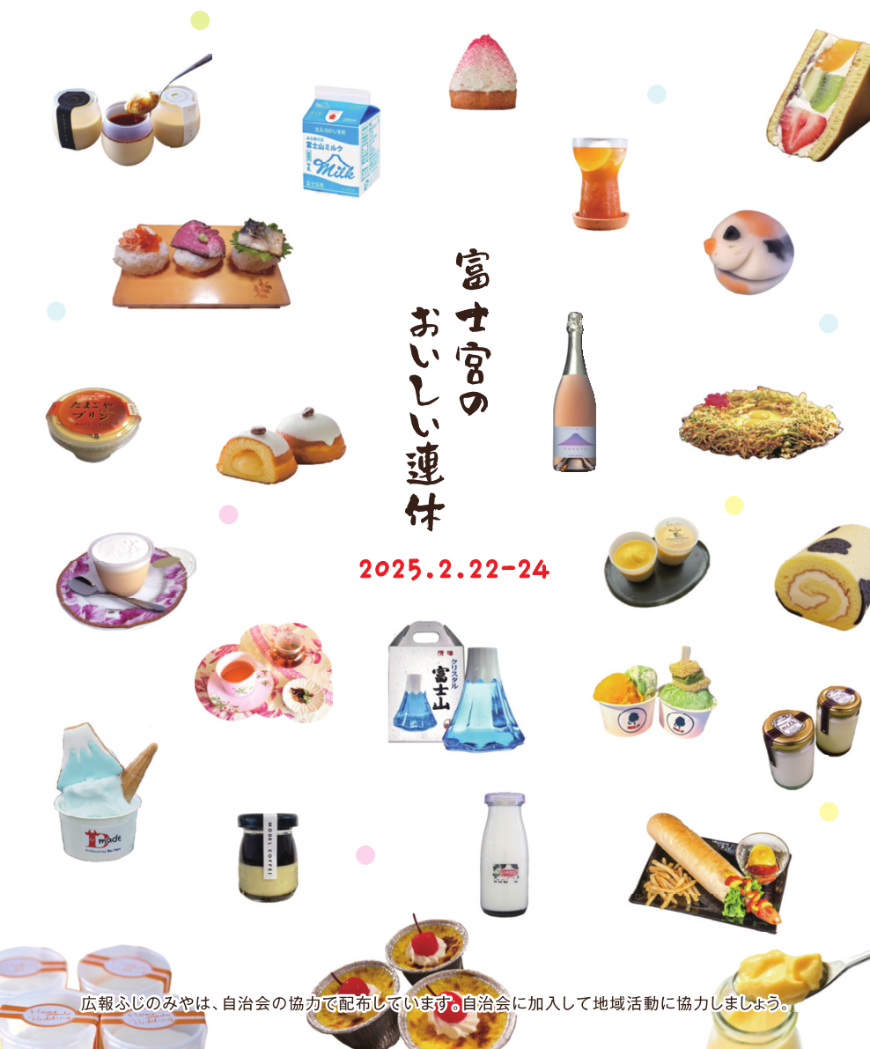

Information on Pregnancy, Children, Childcare

|  |
| --- |
| **If your child get sick suddenly** |
| **Inquiry** Shizuoka Child Emergency Telephone Consultation *(Shizuoka kodomo kyukyu denwa sodan)*  **☎#8000　or 054-247-9910**  **Time** Available 24 hours a day  ※In case of **emergency,** do not hesitate to call **☎119** |

|  |
| --- |
| **Counseling for children** |
| **Inquiry** Family and Child Counseling Section, Children's Future Division  *(Kodomo mirai-ka, katei jido sodan-kakari)* **☎0544-22-1230**  **Time** Weekdays 8:30～17:15    **Inquiry** Child Guidance Center *(Jido sodan jo)*  **For consultation only: ☎0120-189-783**  **Time** Available 24 hours a day |

|  |
| --- |
| **Counseling on abuse** |
| **Inquiry** Child Guidance Center *(Jido sodan jo)*  **For abuse only: ☎189**  **Time** Available 24 hours a day |

|  |
| --- |
| **Counseling on bullying, truancy, attitude toward life, and employment** |
| **Inquiry** Youth Counseling Center *(Seishonen sodan center)*  Elementary and Junior high school students: **☎0544-22-0064**  Junior high school students - 39 years old: **☎0544-22-1252**  E-mail Counseling : **e-sodan@city.fujinomiya.lg.jp**  **Time** Weekdays 9:00～17:00 (Until 19:30 on the 2nd and 4th Wednesday of each month) |

|  |  |
| --- | --- |
| **Notice** | **Don't forget to apply for following the revision of the Child Allowance System.** |
| Under the revision of the child allowance system as of October 2024, those who are raising a child until the end of the first fiscal year after the child reaches 18 years of age can receive the allowances regardless of the income limits.  Those who needed to apply were mailed a notice in August 2024.  If you apply by Monday, March 31, you will be eligible to receive the revised allowances starting from October 2024.  **Application** Send us the application form by mail or submit it at the counter of the Children's Future Division *(Kodomo Mirai-ka)* , 1st floor of City Hall  **Others** For more information, please visit the city's official website.  **Inquiry** Children's Future Division *(Kodomo Mirai-ka)* ☎0544-22-1146 | |



The Japanese fiscal year begins in April and ends in March.

Example:

FY2024 (from April 2024 to March 2025)

FY2025 (from April 2025 to March 2026)

|  |  |  |  |  |
| --- | --- | --- | --- | --- |
|  | Male | Female | Total | Household |
| Population | 63,069 | 63,788 | 126,857 | 59,291 |
| Month to month basis | (-93) | (-67) | (-160) | (-22) |

**The number of population and households**  (As of January 1st, 2025)

**February 23 is “Mt. Fuji Day”**

|  |  |
| --- | --- |
| **Notice** | **Free service on all Miya Bus lines** |
| **Date** February 23 (Sun) only    がつ にち  ふ じ さん ひ  **Others** The Central Loop Bus No. 1 and No. 8 will be cancelled on that day.  Please contact us in advance if you need to use a wheelchair ramp.  **Inquiry**  **■Central, Southeast, and North Loop Buses**  Fujikyu Shizuoka Bus ☎0544-26-8151  **■Buses other than the above**  Shinko Bus ☎0545-60-1234 | |

Information on Seniors, Health, Medical Care, Nursing Care, and Disabilities

|  |  |
| --- | --- |
| **Notice** | **Information from Fujinomiya City General Hospital** |
| After March, a letter of referral from your family doctor is required for your first visit to the dermatologist.  **Inquiry** Medical Affairs Division (*Iji-ka*) ☎0544-27-3151 | |

|  |  |
| --- | --- |
| **Notice** | **Pension Consultation** |
| We provide consultation regarding pension claim procedures and pensions you are receiving, etc.    **Date & Time**  Weekdays: 9:00-16:00 (until 18:00 on Mondays)  The 2nd Saturday: 10:00-15:00  **Place** Fuji Pension Office *(Fuji Nenkin Jimusho)* Adress: 3-5-33 Yokowari, Fuji City  **Application** Appointments can be made by phone one month prior to the desired date.  *You need something that shows your basic pension number.  **Inquiry** Japan Pension Service (Weekdays: 8:30-17:15)  ☎ 0570-05-4890 (*for appointment only)  If you are using a phone number beginning with 055, please call 03-6631-7521 | |

Information on Events, Applications, Notices, National Insurance, Pensions, Subsidies, Aids, Businesses

|  |  |
| --- | --- |
| **Notice** | **Please inform us of any damage or anomalies on the city roads.** |
| The City is repairing potholes and sinkholes on the roads in the city, as well as inspecting and repairing damaged gutters and gutter covers.  If you find any damage or anomalies on the roads, please let us know.  You can also send a report from the "いわせ・(Inquiry / Report)" on the"くらし(Life)" page of the Fujinomiya City Official LINE.  **Inquiry** Road Division *(Doro-ka)* ☎0544-22-1240  *Please call the staff on duty on weekends, public holidays and after hours. ☎0544-22-1111 | |

|  |  |
| --- | --- |
| **Notice** | **Please do not dispose of food scraps or used oil down the sink.** |
| Clogged drains and overflowing sewage can cause bad odors and pest outbreaks. When using a sewer or septic tank, please be careful of the following points.  ■Do not dispose of garbage such as food scraps, leftovers, salad oil, paper scraps, cigarette butts, gum or hazardous materials such as waste oil, thinner down the kitchen sink or washbasin.  ■Do not use hydrochloric acid or other deleterious substances to clean toilet bowls.  **Caution:** Never turn off the power to the septic tank in order not to weaken the microorganisms that clean the water!  **Inquiry** Sewerage Division *(Gesuido-ka)* ☎0544-22-1173 | |

|  |  |
| --- | --- |
| **Subsidy** | **Subsidies for the purchase of bicycle helmets** |
| We subsidize a part of the purchase cost of bicycle helmets.  **Subsidy amount:** 1/2 of the purchase cost (up to 2,000 yen)  **Eligible Products** Bicycle helmets that meet one of the following standards: ①SG Mark, ②JCF Mark, ③CE Mark, ④GS Mark, ⑤CPSC Mark, and purchased at a store in the city  **Application** Submit the application form (available at the Traffic Management Section on the 5th floor of City Hall or on the city's official website), and the receipt for the purchase of a helmet by mail, online or at the counter.  **Others** Limited to one per person.  **Inquiry** Traffic Management Section *(Kotsu Taisaku-shitsu)* ☎0544-22-1152  **HP** トップページ>市民の皆さんへ>安心・安全なまちづくり>交通安全>自転車乗車用ヘルメット補助金 | |

**Schedule from February 1st to March 10th**



**■First–aid Medical Treatment Center *(Kyukyu Iryo Center)***

**☎0544-24-9999 / Fax: 0544-24-9995 /** **Address: 12-1 Miyahara, Fujinomiya, Zip Code 418-0005**

|  |  |  |
| --- | --- | --- |
| **Medical treatment subject** | **Day** | **Time** |
| **Internal medicine (*Naika*), Pediatrics (*Shonika*), Surgery (*Geka*)** | Weekdays | 19:00-8:00 on the next day |
| Saturdays | 14:00-8:00 on the next day |
| Sundays, Public holidays,  Year–end and New year holidays | 8:00-8:00 on the next day |
| **Dentistry (*Shika*)** | Sundays, Public holidays,  Year–end and New year holidays | 9:00-17:00  *Reception: until 16:30 |

*If your condition is severe, dial **119** for ambulance. Make sure to bring your **health insurance card** with you.

**■Emergency Ophthalmological Clinics *(Ganka)*** **Open: 9:00-17:00**

*Please make sure to contact the clinics beforehand as they may change.

|  |  |  |
| --- | --- | --- |
| **Date** | **Clinics name/ Address** | **Tel** |
| February 2 | Nagano Iin/ Yunoki, Fuji city | 0545-60-7100 |
| February 9 | Nakagawa Ganka/ Oiwa | 0544-29-6000 |
| February 11 | Abe Ganka Iin/ Yunoki, Fuji city | 0545-61-5810 |
| February 16 | Asaoka Ganka Iin/ Imaizumi, Fuji city | 0545-52-0745 |
| February 23 | Yamamoto Ganka Clinic/ Ishizaka, Fuji city | 0545-21-0069 |
| February 24 | Kato Iin/ Hina, Fuji city | 0545-34-0011 |
| March 2 | Tenjin Ganka Iin/ Wakanomiya-cho | 0544-23-7050 |
| March 9 | Komori Ganka Clinic/ Denbo, Fuji city | 0545-21-0333 |

**■Emergency Obstetrics and Gynecology Clinics *(Sanfujinka)* Open: 9:00-24:00**

*Please make sure to contact the clinics beforehand as they may change.

|  |  |  |
| --- | --- | --- |
| **Date** | **Clinics name/ Address** | **Tel** |
| February 2 | Fujinomiya City General Hospital/ Nishiki-cho | 0544-27-3151 |
| February 9 | Tenjin Sanfujinka Iin/ Wakanomiya-cho | 0544-24-1322 |
| February 16 | Otabe Sanfujinka Iin/ Hibarigaoka | 0544-23-1182 |
| February 23 | Bando Ladies Clinic/ Sugita | 0544-28-5800 |
| March 2 | Fujinomiya City General Hospital/ Nishiki-cho | 0544-27-3151 |
| March 9 | Tenjin Sanfujinka Iin/ Wakanomiya-cho | 0544-24-1322 |

**■Blood Donation**

|  |  |  |
| --- | --- | --- |
| **Date** | **Clinics name/ Address** | **Time** |
| February 2 | Fujinomiya Sengen Taisha Shrine / Miya-cho | 9:00–16:00 |
| February 8 | AEON Mall Fujinomiya/ Asama-cho | 9:30–16:00* |
| February 15 | AEON Mall Fujinomiya/ Asama-cho | 9:30–16:00* |
| February 23 | AEON Mall Fujinomiya/ Asama-cho | 9:30–16:00* |

* Not implemented from 12:00-13:15

**Inquiry** Welfare Planning Division *(Fukushi Kikaku-ka)* **☎** 0544-22-1457

■**Due Dates for tax or other payments**

|  |  |
| --- | --- |
| **Date** | **Taxes to be payed** |
| February 3 | Municipal and prefectural resident tax (4th term) |
| Natinal Health Insurance Tax (7th term) |
| Long Term Care Insurance Premium (7th term) |
| February 28 | Medical Insurance Premium for the elderly (7th term) |
| Water charges and Sewerage charges (for January usage) |
| Child care fee (for February usage) |
| Public housing fee / Parking fee (for February usage) |
| March 3 | Property tax / City planning tax (4th term) |
| Natinal Health Insurance Tax (8th term) |
| Long Term Care Insurance Premium (8th term) |

**■Counseling and Consultation** *Not implemented on public holidays.

**〈Place: Citizen counselling room, 1st floor, City Hall〉**

|  |  |
| --- | --- |
| **Consultation** | **Date & Time** |
| 1. General counseling　*(Ippan sodan)* 2. Counseling for non-Japanese residents　*(Gaikokujin sodan)* | Monday-Friday 8:30-17:00  (*Reception: until 16:30) |
| 1. Counseling on consumer affairs　*(Shohi seikatsu sodan)* | Monday-Friday 9:00-16:00 |
| ④ Attorney　*(Bengoshi sodan)*  *Appointment is required (by 12:00 on the day before the consulting day, seats are limited to the first 7 people) | February 5, 12, 19, 26  (13:30- until the end of the consultation) |
| ⑤ Judicial scrivener *(Shihosyoshi sodan)*  *Appointment is required | February 14 13:00-16:00 |
| 1. Licensed tax accountant *(Zeirishi zeimu sodan)*   *Appointment is required | February 4 13:00-15:00 |
| 1. Administrative scrivener *(Gyosei syoshi sodan)* | February 21 13:30-16:30 |
| 1. General administrative counseling *(Gyosei sodan)* | February 13 10:00-15:00 |
| 1. Consultation on the human rights *(Jinken sodan)* | February 18 13:00-16:00 |
| 1. Consultation on side jobs *(Naisyoku assen)* | Mondays and Thursdays 9:00-16:00 |
| 1. Patent attorney　*(Benrishi sodan)* *Appointment is required. | February 28 15:00-17:00 |
| 1. Business start-up consultation *(Sogyo sodan)*   *Appointment is required. | February 25 10:00-15:00 |

①,③-⑨ Community Service Division *(Shimin Seikatsu-ka)*

② Citizen Exchange Division *(Shimin Koryu-ka)*

⑩-⑫ Commerce and Industry Division *(Syoko Shinko-ka)*

**☎** 0544-22-1196

**☎** 0544-22-1246

**☎** 0544-22-1295

**Inquiry**

**〈Place: Meeting Room 510, 5th Floor, City Hall〉**

|  |  |
| --- | --- |
| **Consultation** | **Date & Time** |
| Real estate transaction agent *(Takuchi tatemono torihikishi sodan)* | February 12 13:00-15:00 |

**Inquiry** Construction and Housing Division *(Kenchiku Jyutaku-ka)* **☎** 0544-22-1163

**〈Place: Meeting Room 111, 1st Floor, City Hall〉**

|  |  |
| --- | --- |
| **Consultation** | **Date & Time** |
| Pension consultation *(Nenkin sodan)* *Appointment is required. | February 27 10:00-15:00 |

**Inquiry** Fuji Pension Office in Fuji city*（Fuji Nenkin Jimusho）* **☎** 0545-61-1900



**富士宮市**

FUJINOMIYA　CITY

■**City Hall Open Days on Holidays: We open on the first Sunday of each month.**

**February 2 (Sun)**

**March 2 (Sun)**

**8:30-17:00**

|  |  |
| --- | --- |
| **Division & Phone number** | **Services** |
| Citizen Registration Division  *(Shimin-ka)*  **☎** 0544-22-1134〈Certification and My Number Card〉  **☎** 0544-22-1135〈Family Register and Address〉 | * Submission for Family Register *(koseki)* (birth, marriage, death, etc.) * Submission of change of residence (moving into the city, moving out of the city, moving within the city, etc.) * Application for seal *(inkan)* registration and abolition * Issuance of various certificates (certificate of residence*(jyuminhyo)*, Family Register*(koseki tohon, koseki syohon)*, certificate of seal*(inkan)* registration) * Receiving passports * Procedures for applying for My Number Card     The services we handle are different from normal days. For details, please call or visit the city's official website. |
| Insurance and Pension Division  *(Hoken Nenkin-ka)*  **☎** 0544-22-1138 | * Qualification and disqualification for National Health Insurance |
| Child Future Division  *(Kodomo Mirai-ka)*  ☎ 0544-22-1146 | * Application for Child Allowance and Child Medical Expense Beneficiary Certificate |
| Tax & Premium Collection Division  *(Shuno-ka)*  ☎ 0544-22-1129〈Payment〉  ☎ 0544-22-1128〈Certification〉 | * Payment of city taxes, etc. and Consultation on payment * Issuance of tax certificates   ※Appointment is required in advance for tax consultation.  ※Tax exemption certificates, etc. that require a declaration cannot be issued |

■**After-hours service: Every Wednesday until 19:00pm**

*No services if a public holiday falls on a Wednesday.

|  |  |
| --- | --- |
| **Division & Phone number** | **Services** |
| Citizen Registration Division  *(Shimin-ka)*  **☎** 0544-22-1134 | * Application for seal *(inkan)* registration and abolition * Issuance of various certificates (certificate of residence*(jyuminhyo)*, family register*(koseki tohon, koseki syohon)*, certificate of seal*(inkan)* registration)     The services we handle are different from normal days. For details, please call or visit the city's official website. |
| Tax & Premium Collection Division  *(Shuno-ka)*  ☎ 0544-22-1129 | * Payment of city taxes, etc. and Consultation on payment * Issuance of tax certificates   ※Appointment is required in advance for tax consultation.  ※Tax exemption certificates, etc. that require a declaration cannot be issued |

